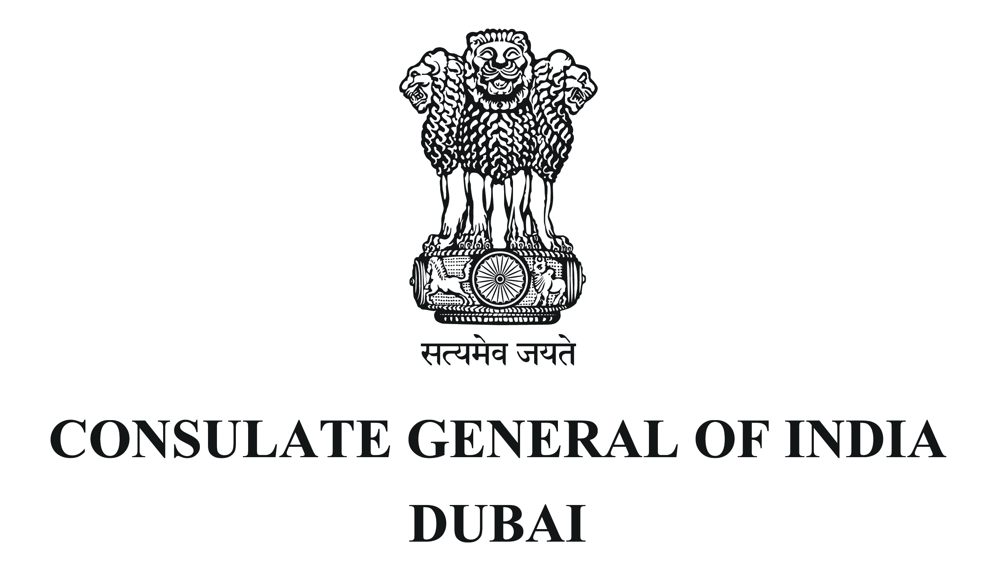
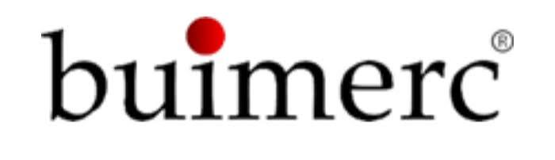


Dubai Future District Fund and Buimerc Corporation Ltd. agree on a strategic collaboration to strengthen Dubai’s venture capital ecosystem and UAE-India innovation ties
- Collaboration aims to strengthen ties with India’s investment ecosystem in Dubai while attracting capital, talent and expertise
Dubai, UAE — 02 November, 2026: Dubai Future District Fund (“DFDF”) and Buimerc Corporation Ltd (“Buimerc”) today agreed on a strategic cooperation at the Consulate General of India in Dubai, in the presence of H.E. Dr. Deepak Mittal, Ambassador of India to the UAE, Dr. Vishnu Vardhan Reddy, Consulate General of India in Dubai and other dignitaries.
The statement sets out the two organisations’ shared intention to explore cooperation in supporting Dubai’s venture capital ecosystem. Areas include sharing market insight and knowledge, helping founders and venture managers establish a presence in Dubai, and running joint ecosystem initiatives such as founder programmes, delegations and events.
The signing reflects the close ties between the UAE and India and the ambitions of the Dubai Economic Agenda (D33) to establish Dubai as a leading global hub for innovation and the new economy. D33 sets out Dubai’s ambition to double the size of its economy and rank among the world’s top three global cities for investing, living and working. A thriving venture capital ecosystem is central to that ambition, and this collaboration supports it directly.
Dubai is increasingly becoming the natural base for Indian founders, fund managers and investors who are looking to build internationally. The cooperation brings together complementary strengths. DFDF, Dubai’s venture capital fund of funds, invests in line with D33 and sits at the centre of Dubai’s venture ecosystem. Buimerc, a Dubai-based investment Company, with Indian roots, brings a generational outlook, deep knowledge of both the UAE and India, and a proven long-term view of building value. Both organisations share a long-term commitment to Dubai’s venture ecosystem, entrepreneurship and on building institutions and relationships that last.
Dr. Deepak Mittal, Ambassador of India, said: “The signing of this MoU is a welcome step towards further strengthening the strong and dynamic ties between India and UAE, by fostering greater collaboration in the venture capital ecosystem and facilitating new opportunities for investment and innovation between our two countries.”
Dr. E. Vishnu Vardhan Reddy, Consulate General of India in Dubai, said, “The partnership between Dubai Future District Fund (DFDF) and Buimerc Corporation Ltd. opens a new chapter for tech and innovation between India and UAE. It will benefit Indian startups to tap into venture funds ecosystem in UAE, while fostering greater cross-border collaboration, among entrepreneurs and investors across both countries.”
His Excellency Khalfan Belhoul, Chairman of Dubai Future District Fund and Chief Executive Officer of the Dubai Future Foundation, said: “The UAE and India share one of the world’s most dynamic partnerships, and innovation is fast becoming one of its strongest pillars. D33 asks Dubai to become the place where the world’s most ambitious founders, investors and ideas choose to build. Long-term, Dubai-based partners such as Buimerc help make that ambition a reality, and together we are strengthening a venture capital ecosystem that will serve Dubai for generations.”
His Excellency Arif Amiri, Chief Executive Officer of DIFC Authority, said: “Dubai’s global position has been built on its ability to create enduring corridors between economies, capital and opportunity. For more than two decades, DIFC has led this work with India, strengthening the connections that enable businesses and investors to grow across borders. Through this collaboration with Buimerc, we will create new pathways for Indian founders and investors to build from Dubai, scale internationally and contribute to the next phase of growth between our two countries.”
Nader Albastaki, Managing Director of Dubai Future District Fund, said: “We are proud to partner with Buimerc. They share our conviction that Dubai’s venture ecosystem is built through long-term relationships, not transactions. Buimerc brings along with itself inherent patience and a deep understanding of India and the UAE, and DFDF brings its network across Dubai’s fund managers and founders. Together, we will help more of the world’s most ambitious companies make Dubai their home.”
Siddharth Balachandran, Executive Chairman and Chief Executive Officer of Buimerc, said: “Indian founders are creating some of the world’s most innovative and ambitious technology companies, while Dubai has emerged as a natural gateway to the region and the global venture capital ecosystem. With deep roots and extensive experience across both markets, we have witnessed the value that greater collaboration can unlock. As a Dubai-based institution, we are proud to partner with DFDF in advancing the venture capital ecosystem envisioned under the D33 agenda, while further strengthening the enduring economic and strategic ties between the UAE and India.”

****

